### Technical Design Document Template

1.0 Revision History

<As you revise the document, list what was changed and when it was changed>

|  |  |
| --- | --- |
| Version | Description |
| 1.0 | Initial document |

2.0 Development Environment

2.1 Game Engine

<Visual Studio 2019>

2.2 IDE

<Visual Studio 2019>

2.3 Source Control procedures

<Github>

2.4 Third Party Libraries

<Raylib>

2.5 Other Software

<2D Pixel art>

3.0 Game Overview

3.1 Technical Goals

<60fps, Working AI>

3.2 Game Objects and Logic

<A list of logical elements in the game, i.e. eat, drink, protect territory (stretch goal), claim more territory (stretch goal)>

3.3 Game Flow

<The player will simply watch a simulation of AI surviving. The player doesn’t do anything except watch, and the simulation ends when all but one AI is dead>

4.0 Mechanics

4.1 Definite Mechanics

- The AI moves for the closest food when it’s hungry

- The AI moves for the nearest source of water when it’s thirsty

- The AI wanders around when not eating or drinking

4.2 Stretch Goal Mechanics

- The AI has territory that they control

- The AI protects their territory and the food inside it

- The AI becomes stronger and braver after eating another AI

- The AI becomes more desperate when their territory shrinks due to food shortage

- The defending AI has an intimidation radius that makes other AI run unless they have enough bravery or desperation.

5.0 Graphics

<Top-down pixels>

6.0 Artificial Intelligence

Definite Behaviours:

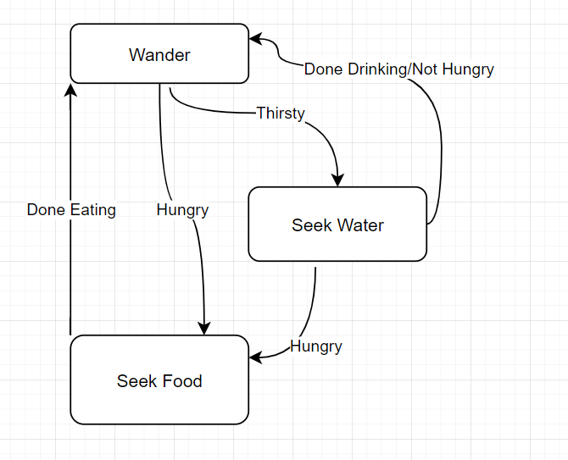

Stretch Behaviours:

7.0 Items

Definite items

|  |  |  |  |
| --- | --- | --- | --- |
| Item | Hunger | Thirst | Description |
| Food | 1 | 0 | Eat food to fill your hunger |
| Water | 0 | 1 | Drink water to refill your thirst |

Stretch Items

|  |  |  |  |  |  |  |  |
| --- | --- | --- | --- | --- | --- | --- | --- |
| Item | Hunger | Thirst | Health | Bravery | Strength | Durability | Description |
| Food | 3 | 1 | 3 | 0 | 0 | 10 | Eat food to fill your hunger |
| Water | 0 | 3 | 5 | 0 | 0 | 999 | Drink water to refill your thirst |
| Corpse | 5 | 2 | 10 | 5 | 5 | 1 | Consume another being to grow stronger |

8.0 Game Flow

9.1 ‘Mission’ / ‘Level’ structure

<One map. It has water acting as an obstacle and has food scattered about randomly>

9.2 Objectives

<The player simply watches the AI do their thing>

9.0 Levels

<Only one level, so no differing behaviours outside of food placement >

10.0 Interface

10.1 Menu

<No menu options, as the player just watches the program play out>

10.2 Camera

<The camera remains still, overlooking the entire map at once>

10.3 Controls

<No controls, as the player isn’t meant to interact with the program>

14.0 Asset List

<List all files needed, along with known attributes >

16.0 Technical Risks

<The only risks in the project are in the stretch goals. Of which, intimidation radius and territories may prove to be the most difficult. If they prove to take too much time, then I’ll have to simply not finish them>